**Relational Schema**

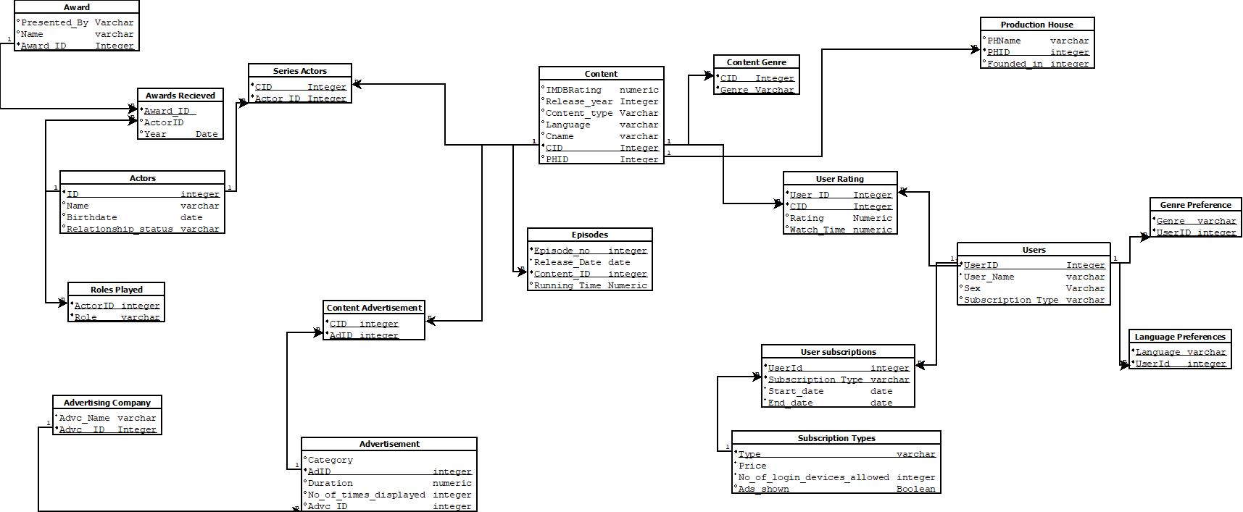

**Minimal FD Set**

**User_Id** -> {username,sex }

**SubsType** -> {Price, No_of_devices, ads_shown}

**{UserID ,Substype}** -> {start_date, end_date}

**{UserID,Content_ID}** -> {rating, watch_time}

**CID** -> {IMDB, Release_year, Content_type, Language, Cname, PHID}

**PHID** -> { PHName, Founded_in}

**{Episode_no, Content ID}** -> {Run_time, Release_date}

**Actor_ID** -> {Name, Birthdate, Relationship_status}

**Award_ID** -> {Name, presented_by}

**{Actor_id, Award_id}** -> {Year}

**AdId** -> {Category, Duration, number_of_times_displayed, Advc_id}

**Advc_id** -> {Advc-Name}

**Proof of the fact that all the relations are in BCNF**

**User relation**

The FD set for the user relation is as follows:

**User_Id** -> {username, sex}

Here the key is the user ID.

Since all other attributes are determined by the key attribute only the user relation is in BCNF.

**Genre Preferences Relation**

Since all the attributes of this relation are prime (i.e part of the key), the relation is in BCNF.

**Language Preferences Relation**

Since all the attributes of this relation are prime (i.e part of the key), the relation is in BCNF.

**User Rating**

The FD set for the episodes relation is as follows:

**{User_id, Content_id}** -> {rating, watch_time}

Here the key is the User_id, Content_id which is a composite key.

Since all other attributes are determined by the composite key attribute only the user relation is in BCNF.

**User Subscription**

The FD set for the user subscription relation is as follows:

**{User_id, Subscription_type}** -> {start_date, end_date}

Here the key is the User_id, Substype which is a composite key.

Since all other attributes are determined by the composite key attribute only the user relation is in BCNF.

**Subscription Type**

The FD set for the user relation is as follows:

**Subs Type** -> {Price,No_of_devices, ads_shown}

Here the key is the substype.

Since all other attributes are determined by the key attribute only the user relation is in BCNF.

**Content Relation**

The FD set for the content relation is as follows:

**CID** -> {IMDB, Release_year, Content_type, Language, Cname, PHID}

Here the key is the CID.

Since all other attributes are determined by the key attribute only the user relation is in BCNF.

**Content Genre Relation**

Since all the attributes of this relation are prime (i.e part of the key), the relation is in BCNF.

**Episodes Relation**

The FD set for the episodes relation is as follows:

**{Episode_no, ContentID}** -> {Run_time, Release_date}

Here the key is the Episode_no, ContentIDwhich is a composite key.

Since all other attributes are determined by the composite key attribute only the user relation is in BCNF.

**Production House relation**

The FD set for the production house relation is as follows:

PHID -> { PHName, Founded_in}

Here the key is PHID.

Since all other attributes are determined by the key attribute only the user relation is in BCNF.

**Content Advertisement Relation**

Since all the attributes of this relation are prime (i.e part of the key), the relation is in BCNF.

**Advertisement Relation**

The FD set for the advertisement relation is as follows:

AdID-> {Category, Duration, number of times displayed, advc_id}

Here the key is AdID.

Since all other attributes are determined by the key attribute only the user relation is in BCNF.

**Advertising Company Relation**

The FD set for the advertisement relation is as follows:

Advc_ID -> {Advc_Name}

Here the key is Advc_ID.

Since all other attributes are determined by the key attribute only the user relation is in BCNF.

**Series Actors Relation**

Since all the attributes of this relation are prime (i.e part of the key), the relation is in BCNF.

**Actors Relation**

The FD set for the actors relation is as follows:

Actor**_**ID -> {Name, Birthdate, Relationship_status}

Here the key is Actor_ID.

Since all other attributes are determined by the key attribute only the user relation is in BCNF.

**Awards recieved**

The FD set for the actors relation is as follows:

{Actor_id, Award_id} -> {Year}

Here the key is {Actor_id, Award_id} which is a composite key.

Since all other attributes are determined by the key attribute only the user relation is in BCNF.

**Award relation**

The FD set for the actors relation is as follows:

Award id-> {Name, presented_by}

Here the key is Award_ID.

Since all other attributes are determined by the key attribute only the user relation is in BCNF.

**Roles played relation**

Since all the attributes of this relation are prime (i.e part of the key), the relation is in BCNF.

**DDL Script**

Create Schema OTT

Create Table Production_House(

PHName varchar,

PHID integer,

Founded_in integer,

Primary Key(PHID)

);

Create Table Content(

IMDBrating Decimal(2),

release_year Integer,

Content_type Varchar,

Langauage varchar,

Cname varchar,

CID Integer,

PHID Integer,

Primary Key(CID),

foreign key(PHID) references Production_House(PHID)

);

Create Table Content_Genre(

CID Integer,

Genre Varchar,

Primary Key(CID,Genre)

);

Create Table Episodes (

Episode_no Integer,

Release_Date date,

CID integer,

Running_Time Numeric,

Primary Key(Episode_no,CID),

Foreign Key(CID) references Content(CID)

);

Create Table Users (

UserID integer,

User_Name varchar,

Sex varchar,

Primary Key(UserID)

);

Create Table User_Rating (

User_ID Integer,

CID Integer,

Rating Numeric,

WatchTime Numeric,

Primary Key(User_ID, CID),

foreign key (User_ID) references Users(UserID),

foreign key (CID) references Content(CID)

);

Create Table Subscription_Type (

SubsType varchar,

Price integer,

No_of_login_devices_allowed Integer,

Ads_shown Boolean,

Primary Key(SubsType)

);

Create Table User_subscriptions (

UserID Integer,

SubsType Varchar,

Start_date date,

End_date date,

Primary Key(UserID, SubsType),

foreign key (UserID) references Users(UserID),

foreign key (SubsType) references Subscription_Type(SubsType)

);

Create Table Genre_Preference (

Genre varchar,

UserID integer,

Primary Key(Genre, UserID),

foreign key (UserID) references Users(UserID)

);

Create Table Language_Preferences (

Language varchar,

UserId integer,

Primary Key(Language, UserId),

foreign key (UserID) references Users(UserID)

);

Create Table Actors (

ActorID integer,

Name varchar,

Birthdate date,

Relationship_status varchar,

Primary key(ActorID)

);

Create Table Series_Actors (

CID Integer,

ActorID Integer,

Primary Key(CID,ActorID),

foreign key (CID) references Content(CID),

foreign key (ActorID) references Actors(ActorID)

);

Create Table Award (

Presented_By varchar,

Name varchar,

Award_ID Integer,

Primary Key(Award_ID)

);

Create Table Awards_Recieved (

Award_ID integer,

ActorID integer,

Year Date,

Primary Key(Award_ID),

foreign key (ActorID) references Actors(ActorID),

foreign key (Award_ID) references Award(Award_ID)

);

Create Table Roles_Played (

ActorID integer,

Roles varchar,

Primary Key(ActorID, Roles),

foreign key (ActorID) references Actors(ActorID)

);

Create Table Advertising_Company (

Advc_Name Varchar,

Advc_ID integer,

Primary key (Advc_ID)

);

Create Table Advertisement (

Category varchar,

AdID integer,

Duration numeric,

No_of_times_displayed Integer,

Advc_ID integer,

Primary Key(AdID),

foreign key (Advc_ID) references Advertising_Company(Advc_ID)

);

Create Table Content_Advertisment (

CID integer,

AdID integer,

Primary Key (CID,AdID),

foreign key (AdID) references Advertisement(AdID),

foreign key (CID) references Content(CID)

);